Purchasing Instructions
Table of Contents
Summary from the staff 1
Most used vendors by department 2
Key terms: 5
Creating and Assigning a Cart 6
UVA Marketplace 8

Summary from the staff
Welcome back!
Just a few reminders as we get this semester going.
When you need to order goods, please either:
1. Place the order yourself in UVA Marketplace (instructions below) or
2. Put a request into OTS and our Fiscal staff will order it for you. Either process will help us ensure that your orders are being purchased properly and tracked accordingly.
As a public university, we are obligated to try to work with contract vendors first before working with other vendors. Additionally, the university has a policy that states we, the department, have an annual purchasing cap of $10,000 per non-contract vendor. After that, we must look at purchasing similar items from contract vendors. Procurement calls this ‘competition’. In other words, we can’t blindly go to Amazon or eBay as the first place to purchase things. We need to look at other vendors.
If the supplier is not in OTS, this does not mean the supplier is not a registered vendor. You will need to enter the new vendor information into OTS (phone number, address, link …). Once we receive the order, we will let you know if the vendor is registered or not. If the vendor is not registered at that time, we may be able to suggest another vendor that might be able to supply your item(s) or request contact information for the vendor you are requesting to purchase your item from. (This will begin the vendor registration process, which may take some time to complete). A registered vendor is a non-contract vendor that is registered through Paymentworks, the system used to maintain information about the vendor, with payment information included. Contract vendors: Vendors that the university has a contract with.
Please try to use UVA registered, SWAM (Small, Women-owned, And Minority-owned) and a small locally owned vendor before you use a website. The Supply Room, for example, is a contracted SWAM vendor that sells office supplies.
Procurement services is pushing for us to use our UVA, SWAM and small locally owned vendors as much as possible. These vendors should be considered first when purchasing products for lab supplies and equipment. When we use our registered vendors, it helps with preventing issues with returns, refunds and sales taxes.
Please keep in mind that Amazon should not be the go-to, but if you do intend to order from Amazon, please put your orders in OTS so that the department fiscal staff can place the order on our business account which is tax exempt.
When using outside vendors, and a problem arises, our fiscal staff spend a significant amount of time out of their workday trying to contact, follow up and provide information to a non-UVA vendor in order to get issues resolved. Sometimes it is difficult to resolve issues such as refunds and returns, which creates additional time away from fiscal duties.
When your items/purchases have been received and you get an email stating the item has been received, please go by the tank room and pick up your item(s) within 48 hours. The ‘tank room’ is in the loading dock, room G066. It’s a punchcode door. The code is the same as the other punch code doors in the building. Please date and sign the packing slip and return it to the fiscal staff in the administrative office. (If you can scan it and email it, even better!). If you cannot pick up the package within 48 hours, please either let the staff know, or send someone else to pick up the package for you. The packing slip is required for the monthly reconciliations on the account that is being charged.
Please refer to the OTS training on the department website to place orders in OTS and review the workday training included in this document for placing orders into workday.
By purchasing through the university and going through the staff, we hope to see a decrease in the number of reimbursements in Workday for purchasing. However, we make exceptions for purchasing items when out in the field.
We understand that when out in the field, things will happen that require an emergency purchase (like a hammer, or you didn’t order enough tags for your samples). We get it. However, this should be the exception, not the rule.

For ANY questions regarding purchasing, please contact the following staff:
Laurie Hammond: Non-grant purchases and (temporarily) for grant purchases.

Most used vendors by department:

CATALOG VENDORS
Vendor | Type
Fisher | Lab supplies etc.
WR | Lab supplies etc.
Henry Schein | Lab supplies etc.
Thermo Fisher | Lab supplies etc.
USA Scientific | Lab supplies etc.
New England biolabs | Lab supplies etc.
Perkins Elmer | Lab supplies etc.
Linde | gas
Thomas Scientific | Lab supplies etc.
Millipore | Lab supplies etc.
McMaster Carr | Industrial equipment and supplies
Grainger | Industrial equipment and supplies
MSC | Industrial equipment and supplies
Mayer | Industrial equipment and supplies
H and D supply | Industrial equipment and supplies
Nolan | Plumbing
Daycon | Cleaning supplies
Fastenal | Industrial supplies
Supply room company | Office supplies
Cavalier computers | Computers
Uva Print | Printing
Dell | Computers
Daly | Computers
Connection | Computers
CDW-g | Computers
B and H | Camera and tv equipment
Examples of non-catalog vendors ok to use | There are literally hundreds of non-catalog vendors
Forestry suppliers
Carolina Biological Supplies
Cole Parmer
Batteries plus
Campbell Science

Figure 1. Flowchart describing order employees should follow when selecting a vendor to purchase from.

Key terms:
UVA Marketplace: A database of supplier catalogs and supplier website links used to purchase goods for academic and business purposes.
Procurement Shopper: From a requisition point of view, the procurement shopper has access to the UVA Marketplace and has the purchasing authority to create requisitions.
Employee as Self: From a requisition point of view, an employee as Self has access to the UVA Marketplace to “window shop”, but they do not have the purchasing authority to create requisitions.
Catalog: Goods or services that can be purchased in UVA marketplace (a digital catalog)
Non-catalog: Goods or services that are not available or solicited in UVA marketplace
Requester: The person who requests a requisition to be made.
Requisition: Request to buy goods and services. Goes through an approval channel before finalized in the form of a Purchase Order. Requisitions are assigned a number.
Purchase Order (PO): A contract between the buyer and seller. Gives specific information like product or services to be delivered, delivery date, and other terms and conditions like price. POs have a separate number.
Requisitioner: The person who completes the requisition request.
Invoice Approval: An action taken by a Purchase Order (PO) requester to approve an invoice for payment.
Note: Catalog items are purchased going to UVA Marketplace and non-catalog items are purchased on the workday itself.

Below are the links for purchasing instructions –
Shopping with Hosted Catalogs in UVA Marketplace
Using Advanced Search in UVA Marketplace
Create Non-Catalog Purchase Requisition
Create Catalog Purchase Requisition
Shopping with Punch out Catalog Suppliers
Find and View Payment Status for Supplier Invoice

Creating and Assigning a Cart

Any employee can create and assign a cart to a Procurement Shopper.

- Log into Workday using the link here: https://virginia.service-now.com/its?id=itsweb_kb_article&sys_id=90022971dbd5d3804f32fb671d9619bc
- Once in Workday, type in global search bar “connect to Supplier”, then click on the task.
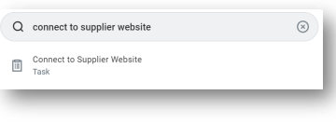
- A pop up screen will come up after clicking the “connect to supplier” task. The ‘Requester’, ‘company’, ‘Currency’ and ‘Ship-to’ auto-populates. Enter manually ‘Deliver-to’, other worktags as given by department. Then click ‘OK’.

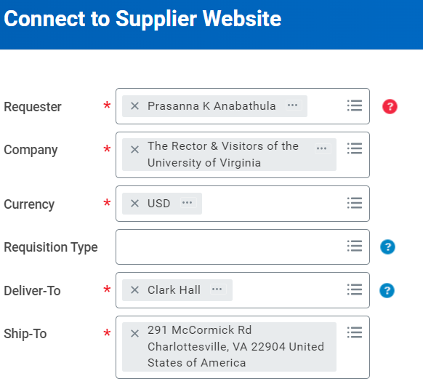
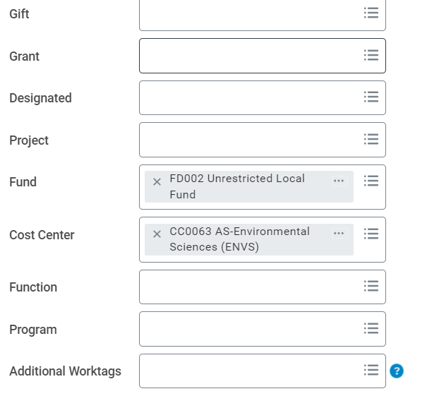

- In the second page, click on ‘Connect’.
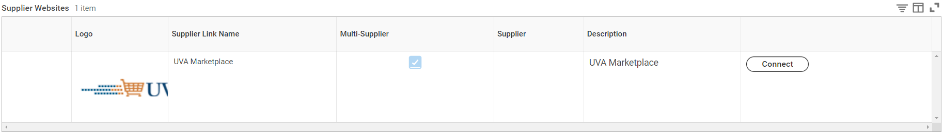

- In the third page, Select the supplier for the item you want to buy. When you click on a supplier, it will redirect you to the supplier page.
- Add items to the cart like you would shop online.
- Once you add all items needed, review the cart and assign to the procurement Shopper. This will route to assigned person to order the item.

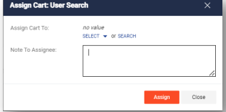

- When assigning a cart, select Search to manually enter details of the assignee. Then select “Search” (Only people with the security role of Procurement Shopper will appear in the Assign To search list.) All purchases that are going to be billed to a Grant should be assigned to the Grant Fiscal Tech and all Non-Grant purchases should be assigned to Laurie Hammond.

UVA Marketplace
Understanding the UVA Marketplace prior to beginning of Requisition of Goods.
Navigating the UVA Marketplace:
Top Banner (grey color): Right side of the UVA Marketplace when clicked, it brings back to home page, left side of the banner to the left of search bar is select an option Triangle icon (when clicked on it, you’ll see options to choose to search results), right side of search bar has Bookmarks Heart icon, Cart Preview, Action items Flag icon, Notification Bell icon, User Person icon.
Note: UVA does not use Action Items Icon.
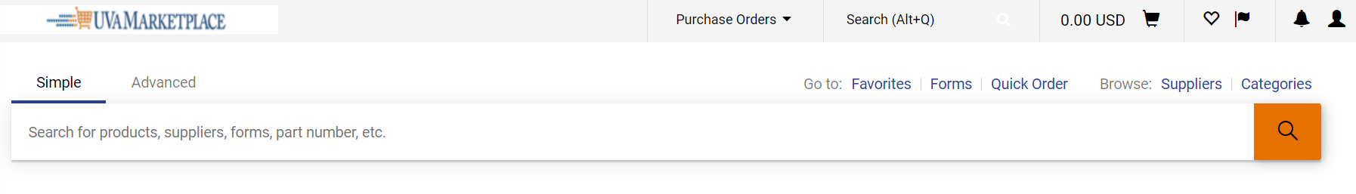
Below the top banner: one can search for products, suppliers, forms, part numbers etc.,
Left Side of below grey bar, browse by suppliers and categories to search for supplier, item, item/part number.
Side bar –

Home – When clicked, it returns to home.
Cart Icon– Gives you access to shopping, my carts and orders, Admin.
Orders – Gives access to search requisitions, POs, Procurement requests, Invoices. My orders can show the requisition, POs, Procurement Requests, Invoices created by you.
Contracts– shows contracts, reports, requests.
Accounts Payable– This dashboard has access to the Accounts payable department.
Suppliers – gives access to Manage Suppliers, Communications, and Performance. Each has sub-areas to choose from.
Sourcing – Gives access to Sourcing Events and Reports
Reporting – Gives access to Supplier ManagementReports Exports

Menu Search

