Reimbursement Guidelines and Instructions
Table of Contents
What is a Worktag? 3
Rules of thumb for grad students and postdocs: 4
Create Expense Report 4
First page of Expense Report 5
Adding Expenses to the Expense Report 7
Add Per DIEM meals Expense Item 8
Itemize for Hotel Accommodations 10
Conference/Workshop Travel 11
Common expenditure types for conference travel: 12
Common expenditure types for field work: 12
International Travel 12
Travel to Eastern shore Steps: 13
Approval Process-Workflow 15

UVA Reimbursement policy: Reimbursements for travel expenses must be submitted upon completion of travel, not before, and within 30 days of the date of return. For all non-travel transactions, expenses must be submitted within 30 days of incurring the expense. All T&E (Travel & Expense) card transactions, regardless of type, must be submitted within 30 days of incurring the expense. Justification and approval from the employee’s supervisor are required in cases where the expense report submission exceeds 30 days. Per IRS guidelines, reimbursements exceeding 60 days (about 2 months) qualify as taxable income for the reimbursed individual and may be treated as such in the finance system.
- DO NOT use abbreviations for meetings and or memberships to orgs. Spell it out.
- Please do not use DOC, DOCX, XLS, or HEIC file types as they are not supported when the expense report is printed. Make sure the documents (receipts, invoices, packing slips Etc.,) are saved in JPG, PDF, or GIF files. Do not upload zipped files, the approver cannot view or access the documents.
- Meal Reimbursements: UVA policy requires itemized receipts for all meal reimbursements. If you turn in a receipt without an itemization, you may not be reimbursed, particularly on grant funds.
  - This is a serious audit issue as some accounts are restricted and do not allow the purchase of alcohol. These include the following: State accounts: DN accounts and any GR (grant account)
  - When purchasing groceries, please do not purchase items that do not have a direct benefit to the account being charged. Purchase of groceries should be reasonable and void of any personal items.
- Expense date: This is the date the expense occurred and not the current date. Please do not use shipping dates.
- Mileage: To claim mileage, do not use home address as starting point. Please use the embedded map calculator tool to calculate mileage. The ‘From’ address should always be 291 McCormick Rd (the place of work). One should avoid attaching gas receipts for travel as the workday accepts ONLY mileage now.
- Combined receipts: Please DO NOT combine receipts.
  - Example: If you made two purchases for Amazon on 7/19/23 please separate them out. Do not combine. Separate them into 2 expense items.
  - Example – mileage: If you traveled from Clark Hall to the Eastern Shore on 7/19/23 and returned on 7/20/23 please do not double the mileage for the round trip. This occurred on two different days and should not be combined.
- Hotel bills: All hotel bills must have a zero balance per UVA policy. If you shared a hotel room and paid half, please make sure that the reimbursement amount is equivalent to half the bill and the statement should indicate the amount charged to your credit card.
- Additional worktags: Attach all worktags given by department, The expense report cannot be approved if it is missing any worktag components. Make sure to add assignee, activity, spend category worktags along with auto-populated worktags. Sometimes, Function must be changed when expensing the item.
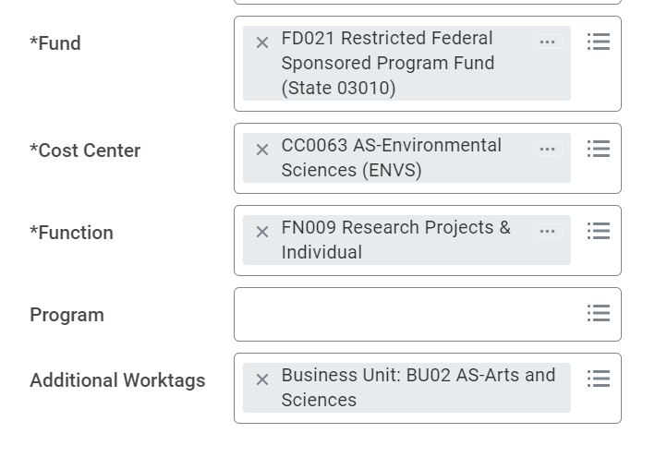

What is a Worktag?

The university has thousands of accounts owned by different departments and schools and used for various purposes. Previously replacing the PTAO system, worktags ‘tag’ transactions to make them easy to find and explain their purpose. Different components of the worktag can tell us who owns the account, how is it funded, what it is used for, etc.
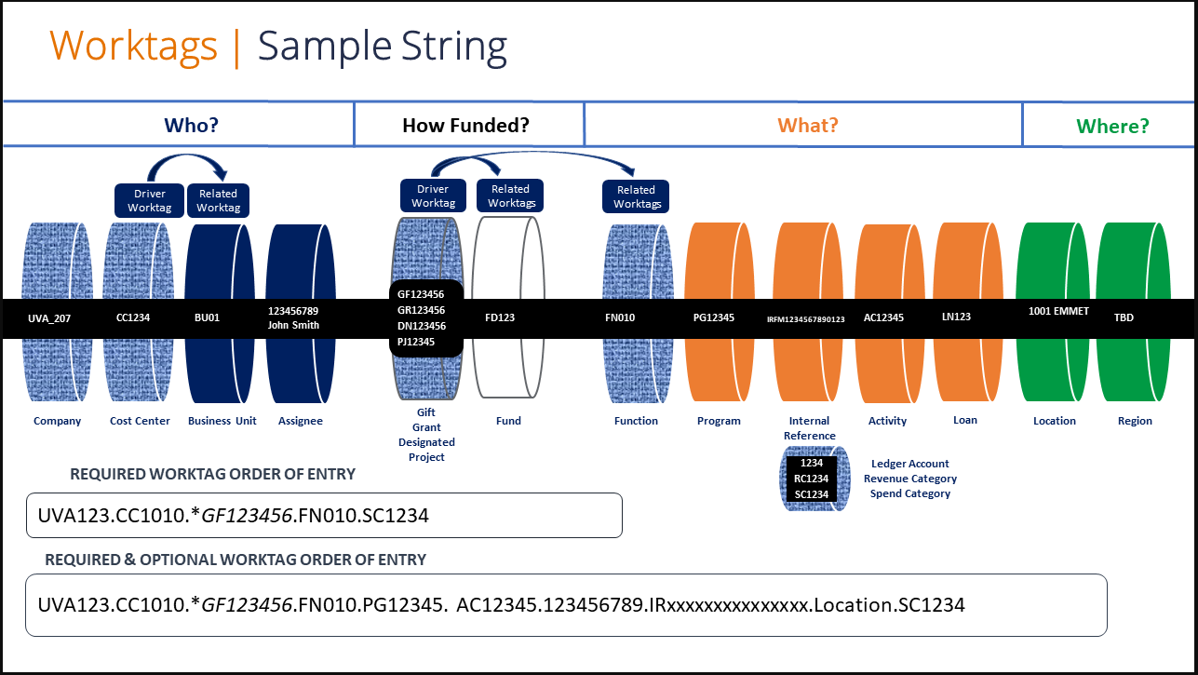
Cost Center (CC): Labels which department owns the funds. CC0063 is for Environmental Sciences.

In a worktag, you will have one of the four following driver worktags. Depending on what you pick will ‘drive’ or autoselect the rest of the worktag components:
Gift (GF): Money given from either a private individual or endowment. Ex: Moore endowment.
Grant (GR): Money awarded by an external sponsor for research such as NSF, NOAA, NIH, etc.
Designated (DN): State money, money allotted by the state.
Project (PJ): Internal money set aside for a specific purpose such as startup.

Additional worktag components that are needed:
Function (FN)
Fund (FD)
Program (PG)
Assignee:

Rules of thumb for grad students and postdocs:
- Ask your faculty advisor for their worktag. All faculty have a list of their respective worktags.
- The staff can provide you with worktags that do NOT belong to faculty such as DN and GF accounts.
- When given a worktag string, use the WHOLE thing and put each component in the appropriate box.

Create Expense Report
(Reimbursements)

Things to gather prior to creation of expense report:
- Receipts (Travel, meals, lodging, vehicle rental, gas etc.,)
- Dates for purchased items, travel, meals etc.,
- Amount (remember to enter exact amount shown on receipt)
- Worktags. Faculty will have a list of their worktags. If you’re a grad student or postdoc, ask your faculty advisor for the worktag. Spend categories (enter in additional worktags tab) are available in this Spend category descriptions.
- If you have a companion accompanying you that will incur expenses, create a Spend Authorization prior to expensing the items. The companion MUST have a bona fide (good faith) business purpose.

- Log into UVA Workday. https://virginia.service-now.com/its?id=itsweb_kb_article&sys_id=90022971dbd5d3804f32fb671d9619bc
  - You must sign in with Netbadge.
- In the search bar at the top, type “create expense report” (or similar search text). Or type a few letters of the word in the search results as shown below.
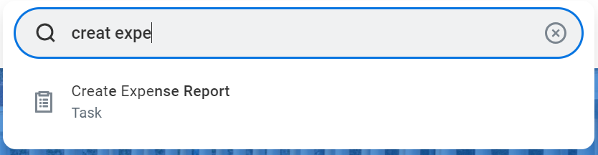

- Select the Create Expense Report task from the Search Results.

First page of Expense Report

- The “Expense Report For”, “name”, “Company”, “Company on Expense Line”, and auto-populate for the fields.

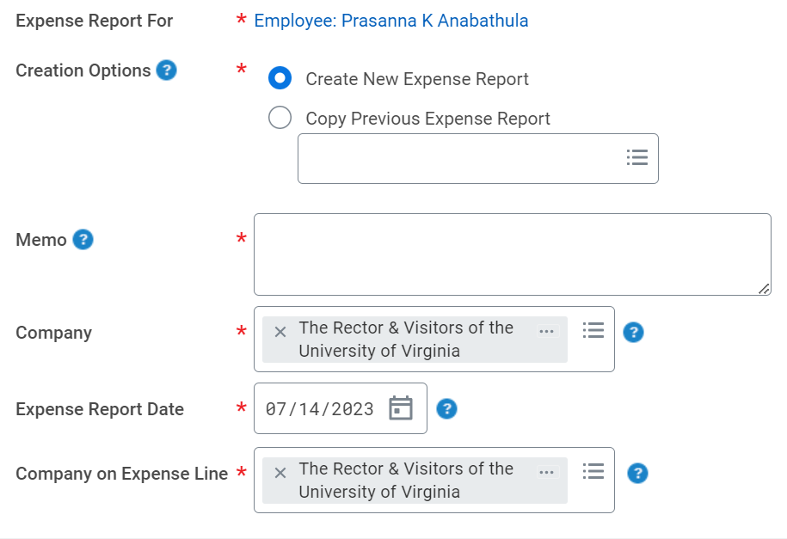
- “Creation options” will default as “Create New Expense Report.”
- If you have expense report in the past, select the expense by selecting “Copy Previous Expense Report.”
- If you have Companion travel, create and submit spend authorization prior to creating expense report. The instructions are saved in another pdf in shared folder.
- “Memo” – Enter a descriptive summary about your reimbursement, including dates, locations, purpose, etc. The memo should be descriptive enough to identify the ‘who, what, where, when, and why’. If you list any organizations, please spell it out. Do not use abbreviations.
Example: Travel reimbursement for ShaRhonda Swann to attend American Geophysical Union (AGU) in Fairbank, AK from December 1-December 7, 2024.

- Enter worktags needed in Gift, Grant, Project, Designated, function, program (see Worktag document for more information).
- Auto-populates Fund and Cost center, and additional worktags. Other worktag components not visible here (such as Activity or Assignee) can be added under additional worktags.

- “Quick Expenses” Tab – scanned receipts uploaded through the mobile app will show up at the bottom of the screen.
Note: To select receipts uploaded via the Mobile app, select the Quick Expenses tab at the bottom of the screen, then select the receipt(s) you want to reimbursed.
- The selected receipts will appear on the left side of the second page of expense report under the Expense Lines tab with an exclamation point in red as shown below.
Note:
- The Header tab will auto-populate based on the details entered in Steps 2 – 10 above. Select this tab to update the title of the report (from the Memo field on the first screen) or the expense report date.
  - Note: You CANNOT change the worktags in the header once you create the expense report. If you need to change the worktags after this point, you need to change them in each individual expense item.
- The Attachments tab enables you to add supporting documentation. Select the tab and click Edit.

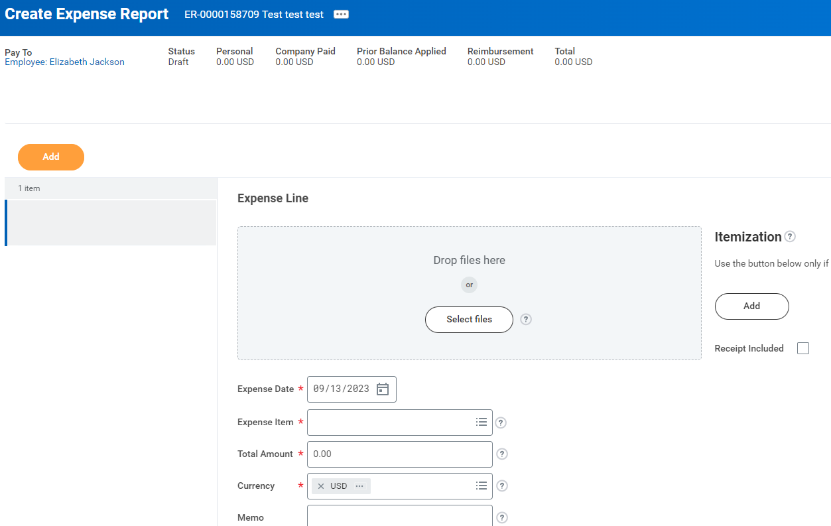

Adding Expenses to the Expense Report
- Click Add to add an expense line for reimbursement.
- Attach the receipt for the expense by clicking on select files or drag and drop files. Supported file types include JPG, PDF, PNG or GIF
- Complete the following required fields – Date (purchase date) and expense item (Spend Category)
  - Depending on what spend category you select will generate different fields to fill out later. Ex: Airfare has fields like departure date, return date, and airline company.
- Fill out all required fields as indicated with a red asterisk.

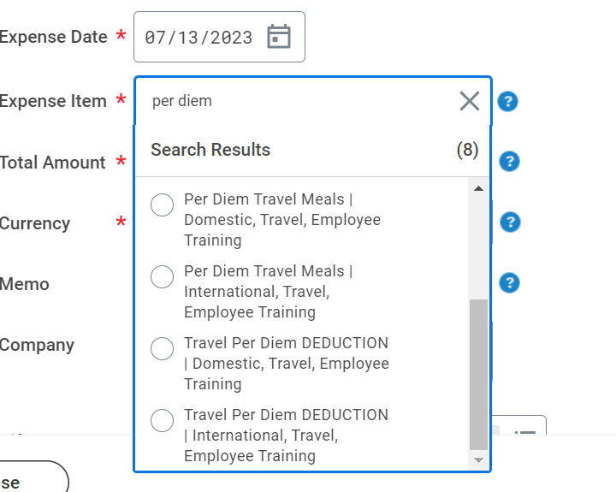

- Click the weird space where the arrow is pointing to save your progress.
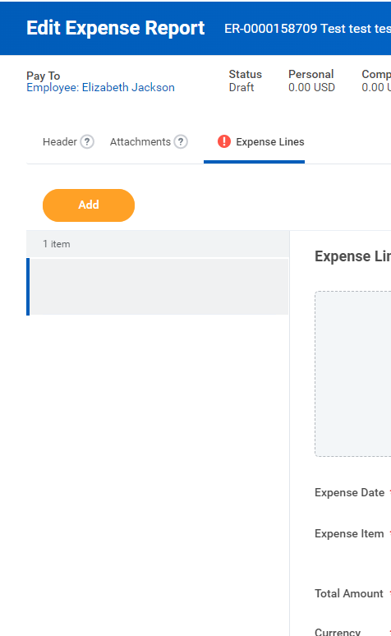
- Repeat steps 1-5 as necessary.
- When you are finished adding expense lines, click ‘Submit’ to submit the expense report.

Add Per DIEM meals Expense Item
Per Diem (meaning per day in Latin), is an allowance of money allotted for food and drink. The daily rate changes depending on the time of year and where you travel to. Most grants allow for per diem.
You do NOT need to save receipts for per diem. However, per diem is very expensive and can eat up grant funds. Ex: As of 9/27/23, the per diem rate for D.C is $79. $79 x 7= $553. Again, these rates will change. Please check with your faculty advisor before traveling.
- Click “Add” to add an expense line for reimbursement
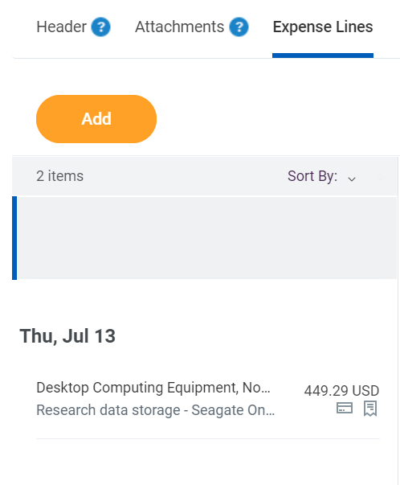
- Under expense line, enter the date(purchase date), expense item(Travel per diem meals domestic) or search for meals, memo, required worktags if not entered in first page of expense report.

- Under Item details, enter arrival date, departure date, destination, and Purchase justification (if not included receipt), check the box receipt included if attached the receipt.
  - Note: Alaska is considered international travel
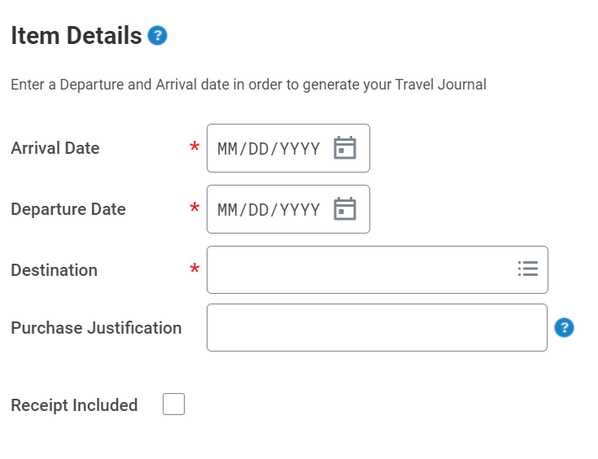
- Once you have entered all the expense items for the report, click Submit to submit the expense report. You have successfully completed this task. It will now be routed based on the business process workflow.

Itemize for Hotel Accommodations
- Under the expense line section, ‘enter date’, ‘expense item’ - Hotel accommodations|Domestic or search by Expense Item Group>Hotel., ‘Total Amount’, ‘Currency’, ‘Memo’.
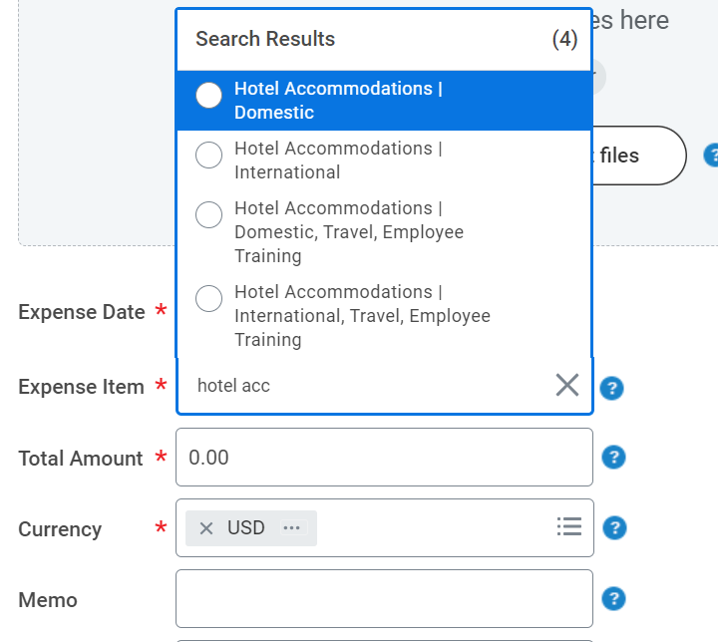
- Under Itemize details, enter ‘Daily Expenses’. The Daily Expenses screen displays and will automatically include items for Hotel Room Charge and Hotel Taxes | Fees. Updates as needed for your expenses.

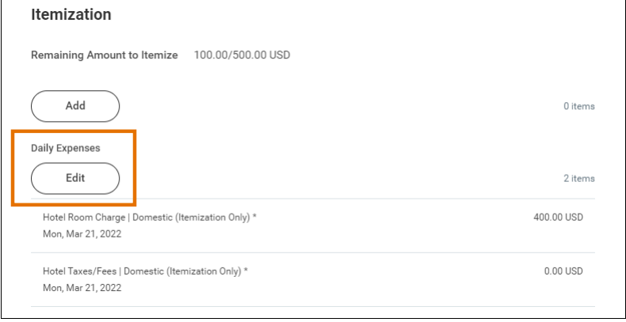
Note: All other hotel expenses will need to be added by clicking “Add” at the bottom of the Itemization screen under ‘Remaining Amount to Itemize’. Once the amount to itemize is zero, you’re good to go.

Conference/Workshop Travel
When the travel is related to training classes, workshops, or conferences, you must use the ‘Travel Employee Training’ expense items.
The Travel Employee Training expense items are required for State reporting purposes.
Itemize Expense Items - Only necessary for hotels and per diem
Click ‘Add’ to itemize expense lines, when needed, to include and track more detailed costs. So, it gets easier for approver to approve the expense report.
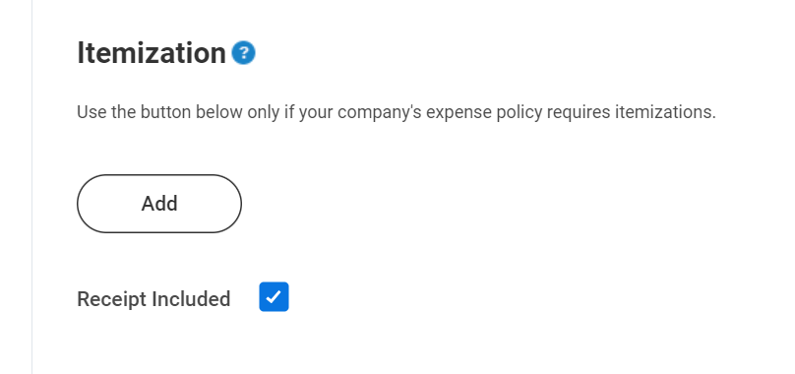

Common expenditure types for conference travel:
Airfare
Baggage fees
Hotel (itemized)
Conference Registration
Abstract fee (publication/advertisement)
Taxis, Public Transit
Food-(Pick one).
Meals-actuals (itemized receipts)
Per Diem

Common expenditure types for field work:
Airfare
Baggage fees
Hotel (itemized)
Car Rental
Gas (rental and state vehicles)
Other-Lab supplies
Mileage (your own vehicle)
Food-(Pick one).
Meals-actuals (itemized receipts)
Per Diem

International Travel
In order to provide protections for you and the university, you will be required to register your itinerary with the university. Graduate students will also need to purchase international health and emergency insurance, which is reimbursable.
Faculty, Staff and Postdocs: https://iso.virginia.edu/faculty-staff-travel
Graduate Students: https://educationabroad.virginia.edu/uva-student-gme-international-travel-registry
If traveling outside the U.S and the receipts are in a different currency, you must change the currency as reflected on the receipt. To do so:
- Click the X to remove USD as the currency used 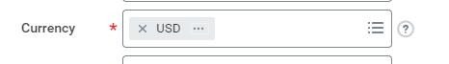
- Type in the currency used 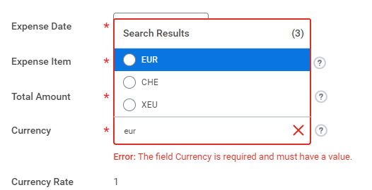

Travel to Eastern shore Steps:
When expensing for routine travel to the Eastern Shore from Charlottesville as per LTER Policy.
- You should use the embedded map calculator tool to calculate the mileage. The ‘from’ address should always be 291 McCormick Rd (place of work) and the destination should be 6364 Cliffs Road, Cape Charles, VA 23310. (should use the Athletic Rate, not the full IRS). For trips other than to the LTER, use the IRS rate.

- When Expensing the item for Eastern Shore Travel per LTER policy, Choose “Mileage” and the “Memo” should say LTER research and date of trips.
  - Each day that you drive, whether you drive one-way or roundtrip in one day, needs to be a separate expense line.
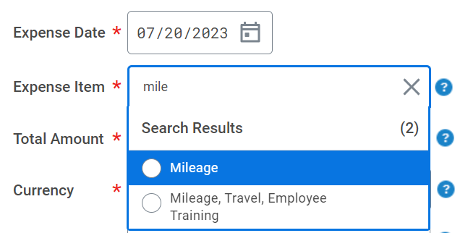

- In item details, “Origin Address” as Charlottesville
“Enter destination Address” as 6364 Cliffs Rd, Cape Charles, VA 23310 and departure as Charlottesville, VA.
“Trip Distance Including Diversions” shows total miles of the trip.
“Vehicle Plan” enter ‘Athletic’.

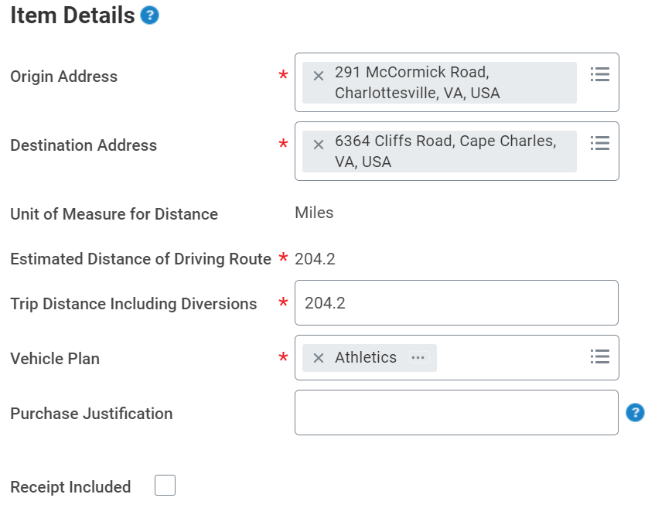
- Toll reimbursement: Add expense line Expense Item enter Toll choose the appripriate for the reimbursement. You must provide the receipt for this to be reimbursed.
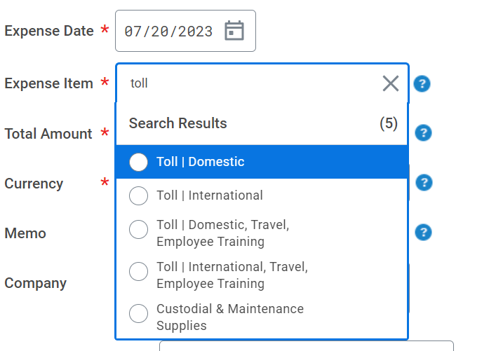

Approval Process-Workflow
Unfortunately, every worktag has a different workflow/approval routing process. In a nutshell, this is the order that most reimbursements will follow. You can check the approval process after you submit it under the ‘Process’ tab. Then you can reach out to the appropriate person if you have questions.

